Scripting Task

Create a shell script to print the HTTP error code of guvi.in & print, the success/failure message based on the error code response

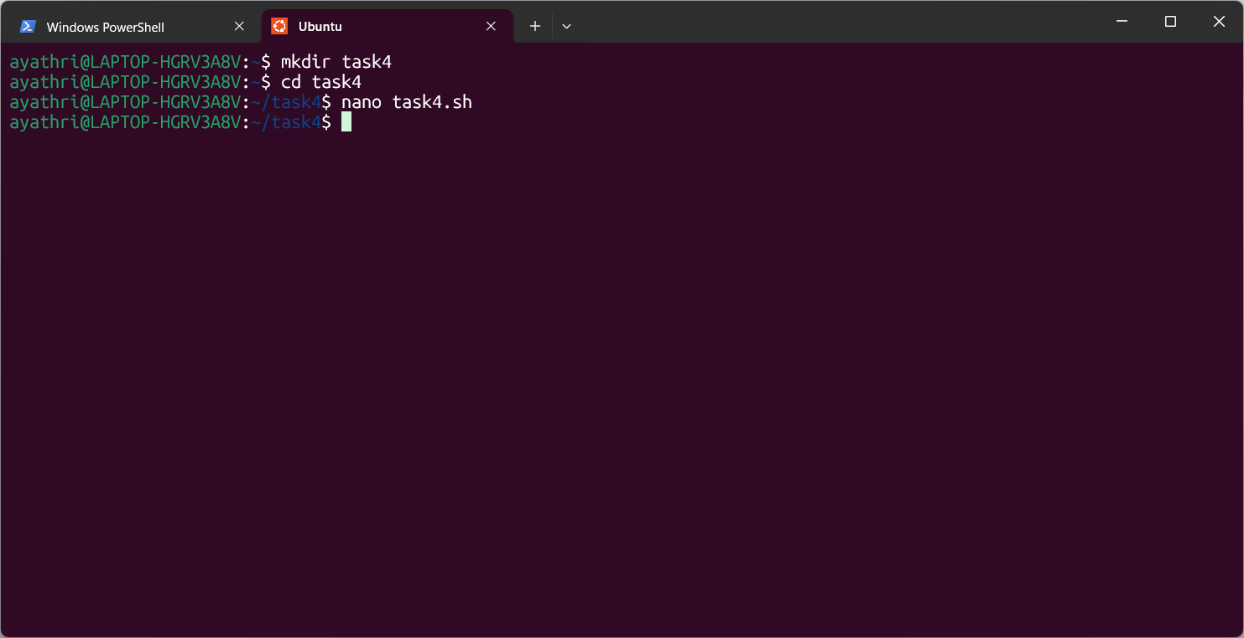

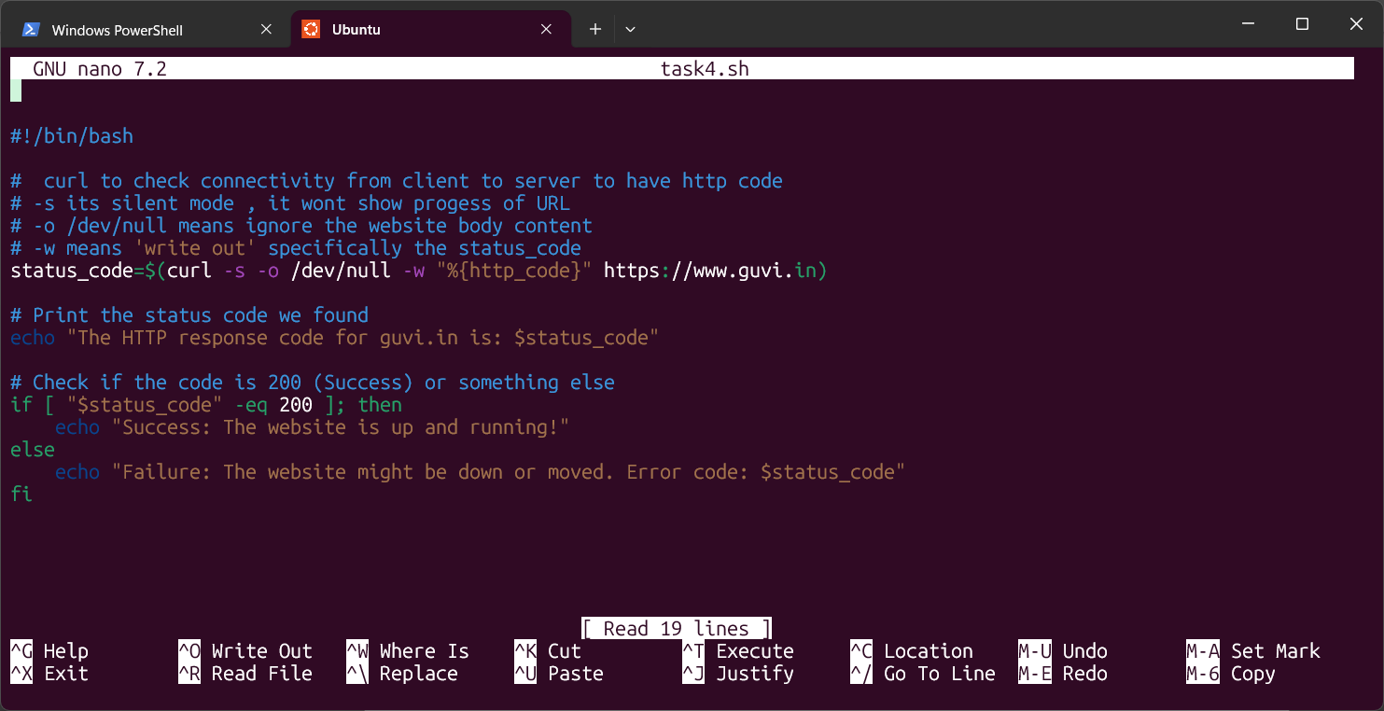

Output:
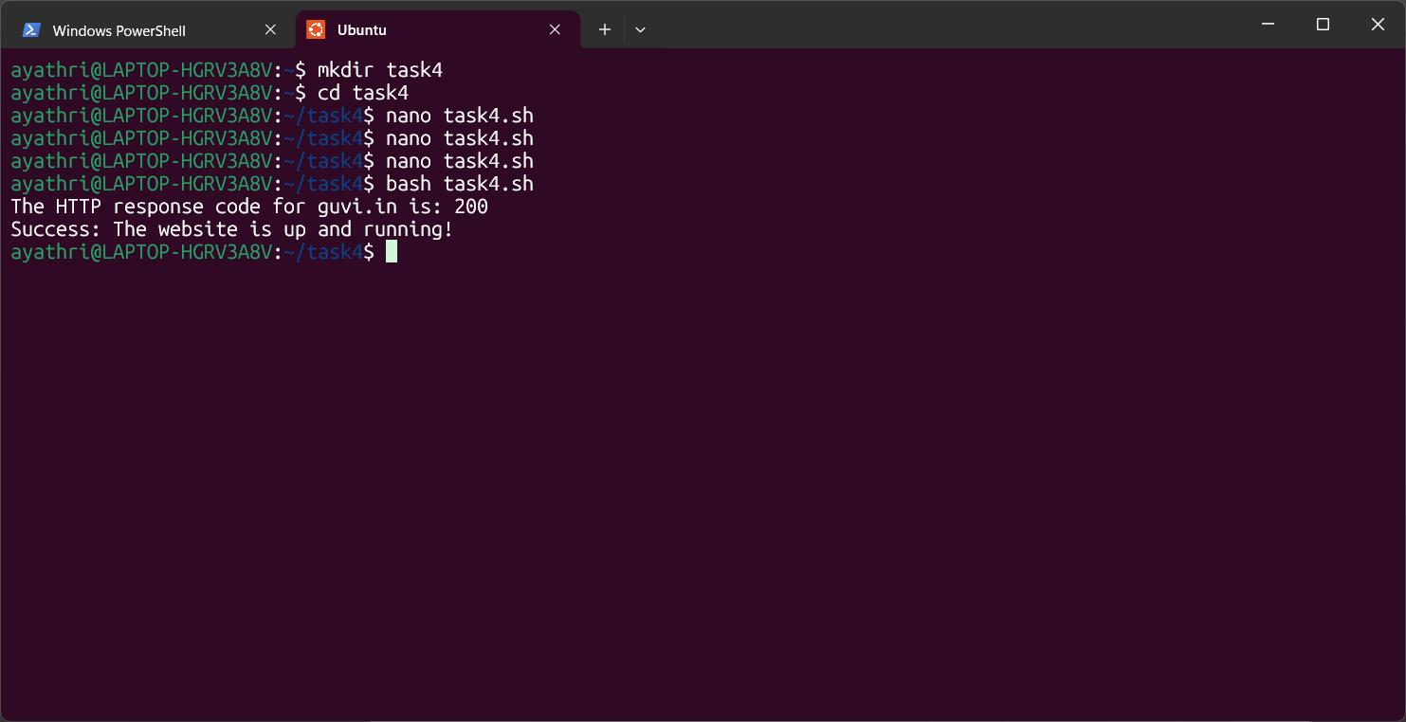

2. Given a file, replace all occurrence of the word "give" with "learning" from 5th line till the end in only those lines that contain the word "welcome"

Text file created with 9 lines with name replace.txt as shown below

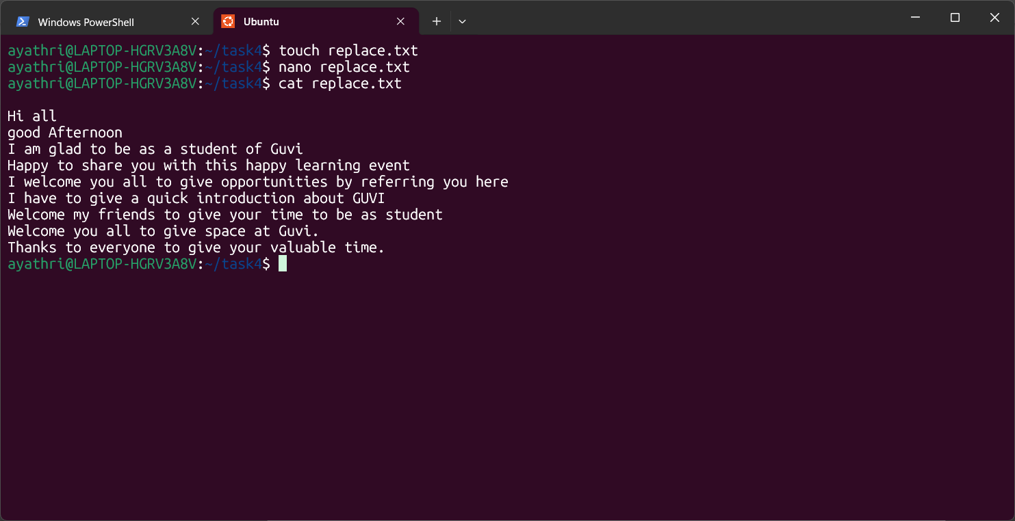

Script with taking backup as given in Shashi material,

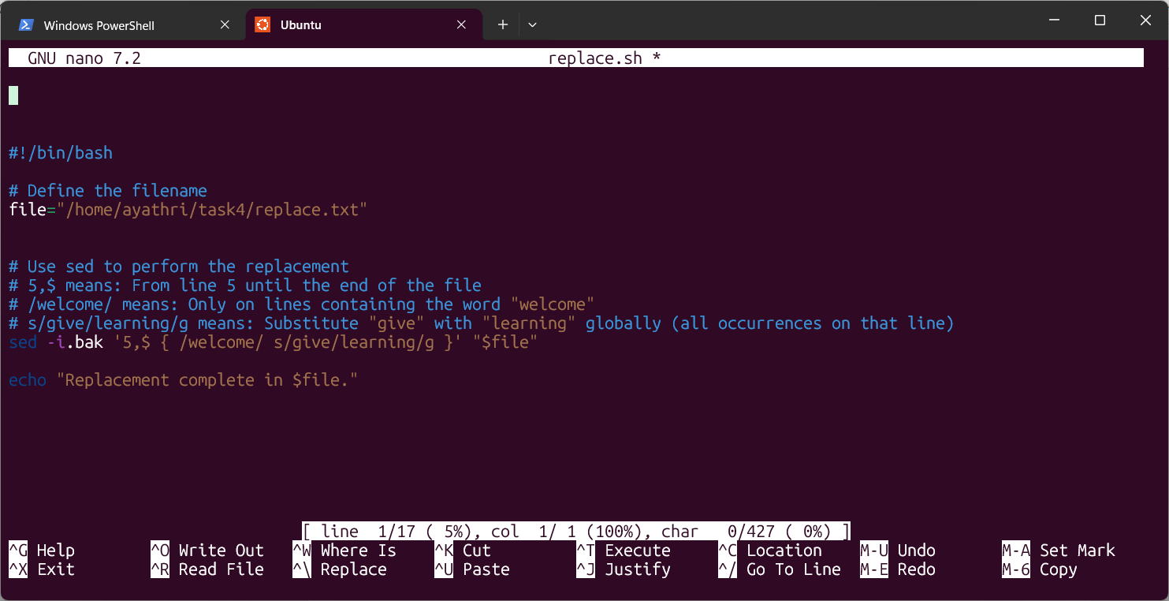

In the below screenshot the word give is not replaced with welcome since welcome has case sensitive hence corrected as per script in the text file.
Second time replaced the word give with welcome as expected.

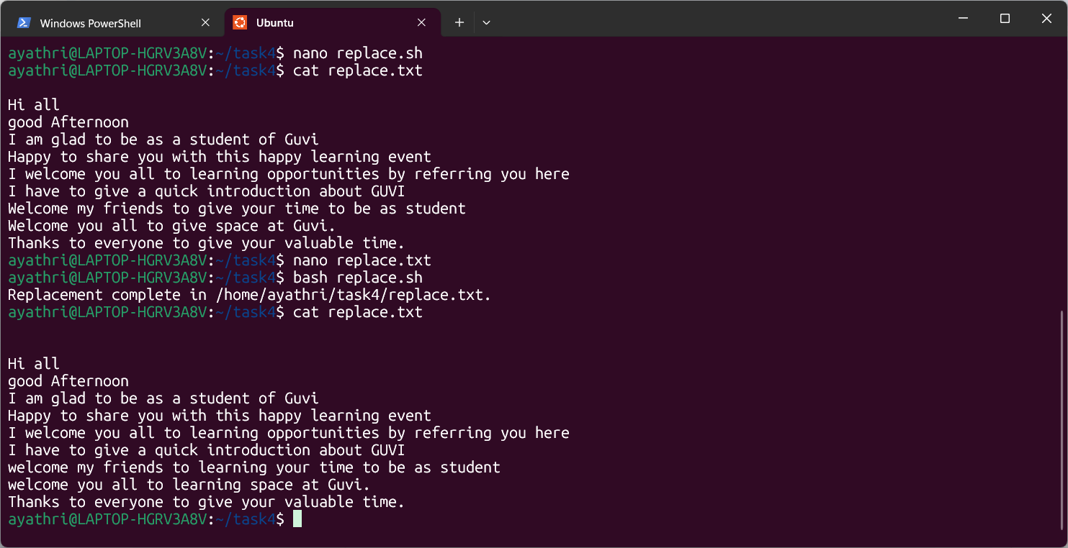

As per code, backup file was created as expected,

